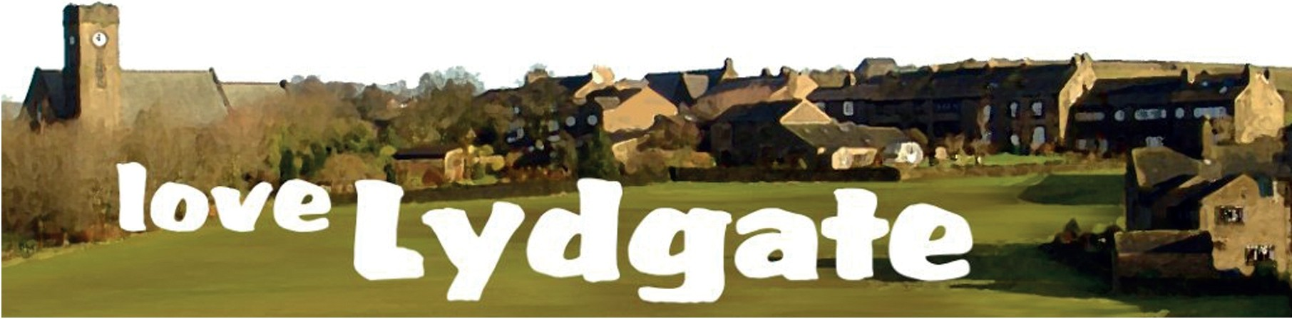

Presents
‘A September Song’

An evening of music & entertainment featuring

Saddleworth Male Voice Choir

Harpist, Sarah Davies

Ukulele Group, ‘Fingers & Thumbs’

and friends

Friday 15th September 2017, St Anne’s Church, Lydgate

Refreshments from 7pm, Concert commences 7.30pm

Tickets £8.00 available from

Janet Watts 01457 875080/Jennifer Greenwood 01457 877935

In memory of Eric Watts

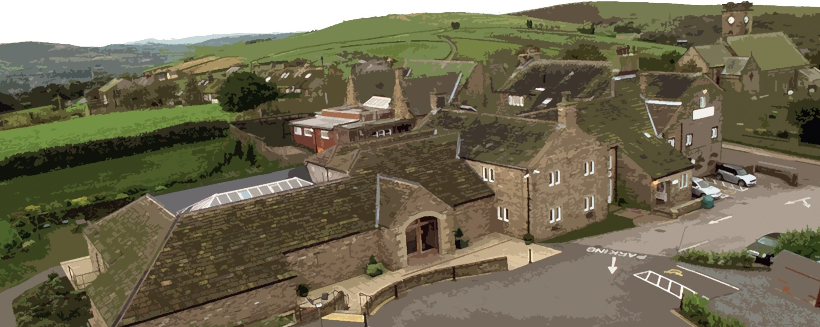
See www.love-lydgate.org.uk or email lovelydgate@btinternet.com

